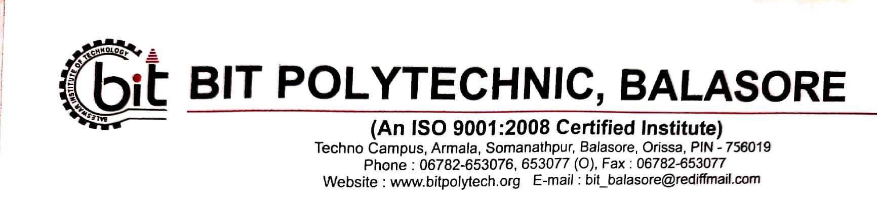
DEPARTMENT OF CIVIL ENGG
LESSON PLAN 4TH SEM
SUB : SOLID WASTE MANAGEMENT

Week | Day | Name of the Teaching Faculty :
1st | 1st | Defination of solid waste, different of solid waste- domestic waste, commercial waste, industrial waste, agricultural waste…..
1st | 2nd | different of solid waste- biomedical waste, E-waste, hazardous waste, institutional waste, etc.
1st | 3rd | Sources of solid waste, Classification of solid waste – hazardous and non- hazardous waste.
1st | 4th | Physical and chemical characteristics of municipal solid waste.
1st | 5th | Storage, Collection and Transportation of Municipal Solid Waste : Collection, segregation, storage and transportation of solid waste.
2nd | 1st | Tools and Equipment: Litter Bin, Broom, Shovels, Handcarts, Mechanical Road sweepers,
2nd | 2nd | Community bin like movable and stationary bin. • Transportation vehicles with their working capacity
2nd | 3rd | -Animal carts, Auto vehicles, Tractors or Trailers, Trucks, Dumpers, Compactor vehicles. Transfer station- meaning, necessity, location.
2nd | 4th | Role of rag pickers and their utility for society
3rd | 1st | Composting of Solid Waste : Concept of composting of waste, Principles of composting process.
3rd | 2nd | Factors affecting the composting process. • Methods of composting – Manual Composting – Bangalore method,
3rd | 3rd | Indore Method, Mechanical Composting – Dano Process, Vermi composting
3rd | 4th | Techniques for Disposal of Solid Waste : Solid waste management techniques – solid waste management hierarchy, waste prevention and waste reduction techniques
4th | 1st | Land filling technique, Factors to be considered for site selection, Land filling methods
4th | 2nd | Area method, Trench method and Ramp method, Leachate and its control, Biogas from landfill.
4th | 3rd | Advantages and disadvantages of landfill method, recycling of municipal solid waste
4th | 4th | Incineration of waste: Introduction of incineration process, Types of incinerators - Flash, Multiple chamber Incinerators
5th | 1st | Products of incineration process with their use, Pyrolysis of waste – Definition, Methods
5th | 2nd | Biomedical and E-waste management : Definition of Bio medical Waste. Sources and generation of Biomedical Waste
5th | 3rd | Classification of Biomedical waste
5th | 4th | Bio medical waste Management technologies.

6TH | 1ST | Definition, varieties and ill effects of E- waste, Recycling and disposal of E- waste.
6TH | 2ND | INTERNAL
6TH | 3RD | QUSTION ANSWER DISCUISSION
6TH | 4TH | MONTHLY TEST

SIGNATURE OF FACULTY H O D IN
DEPT. OF CIVIL ENGG. DEPT. OF CIVIL ENGG.

